

**SRI MUTHUKUMARAN ARTS AND SCIENCE COLLEGE**

**(Affiliated to university of Madras)**

**CHIKKARAYAPURAM, CHENNAI- 600 069.**

**DEPARTMENT OF MATHEMATICS**

**Under scheme of**

**NAANMUDHALVAN**

**Project Title: SUBSCRIBERS GALORE: EXPLORING WORLD’S TOP YOUTUBE CHANNELS**

**Submitted By**

**RUTHRAMANI.P**

[**ruthra1912@gmail.com**](mailto:ruthra1912@gmail.com)

**SIBIRAJ.S**

[**Sibisandy1@gmail.com**](mailto:Sibisandy1@gmail.com)

**SAFANA FATHIMA.K**

[**Safanafathima1509@gmail.com**](mailto:Safanafathima1509@gmail.com)

**SHARMILA.E**

[**sharmilasharmila33864@gmail.com**](mailto:sharmilasharmila33864@gmail.com)

**Team Id: NM2023TMID36016**

**Under the mentor of**

**Mrs. P. JAYANTHI**

**Assistant Professor**

**[jayanthikaviarasan@gmail.com](mailto:jayanthikaviarasan@gmail.com)**

**Department of Mathematics**

1. **INTRODUCTION**

A special feature that distinguishes videos on YouTube from traditional offline videos is that they typically are presented together with user-generated information about those videos. This information is presented in the form of views, (dis)likes, and comments. It forms an essential part of YouTube’s content because it informs viewers about the evaluations that videos receive by their audience. For example, video (dis)likes inform viewers about how positive or negative the overall audience of the video evaluated it. Therefore, we define this information as social information. Despite the prevalence of online social information on YouTube

* 1. OVERVIEW

You tube is a video sharing service where users can watch, like, share and comment and upload their own videos. The video service can be accessed on PCs, laptops, tablets and via mobile phones. The analysis should determine the World’s top YouTube channels includes channels like T-series, coco melon, Sony entertainment, Mr. Beast and more. We may conclude the list of subscribers, brand of channel, languages and further we discussed from these top YouTube channels.

1.2 PURPOSE

The purpose of YouTube is to provide a platform where users can upload, share, and watch videos. The platform was founded in 2005 with the goal of making it easy for people to share videos with one another, and it has since become one of the most popular websites in the world. The top YouTube channels data analyzing country wise subscribers , language wise subscribers ,country wise channel and more will help people to check the subscriber rating, country wise popular channel, language wise famous channels ,etc.,

**2. PROBLEM DEFINITION & DESINGN THINKING**

2.1 Empathy map

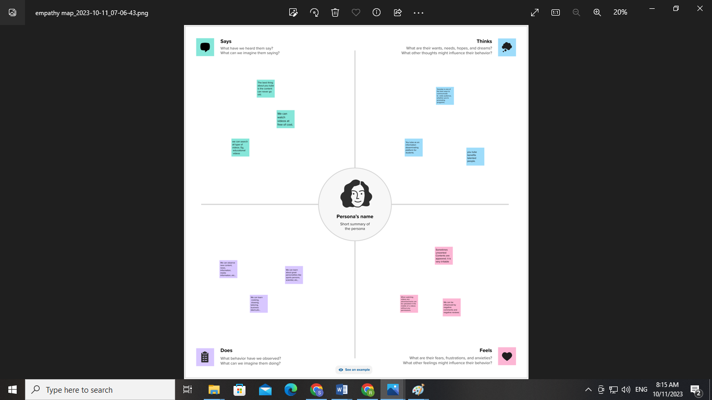

2.2 Ideation & Brainstorming Map screenshots

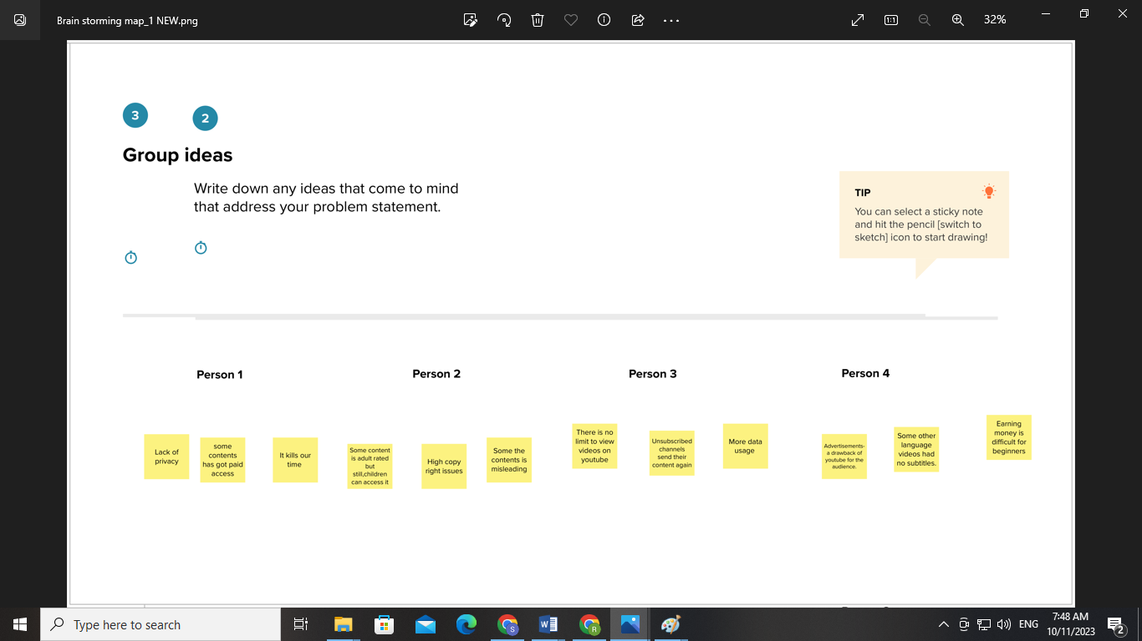

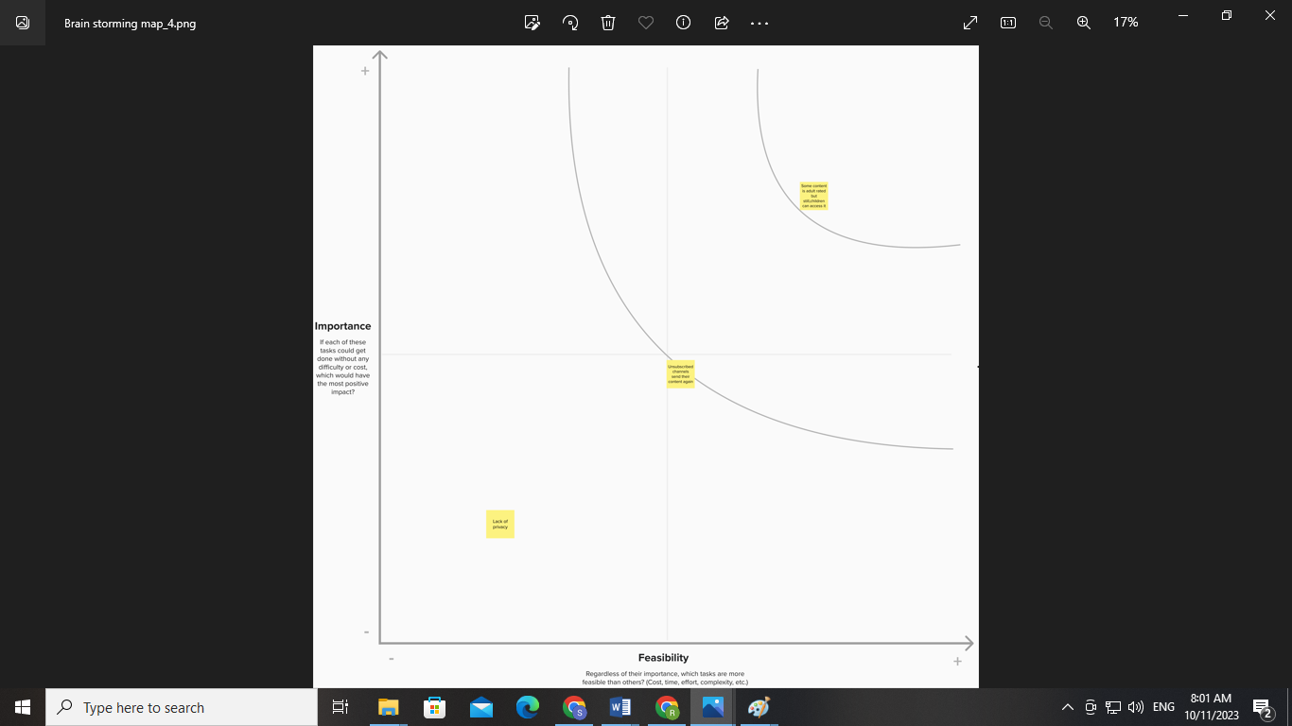

**3. RESULT**

Rank Wise Channel

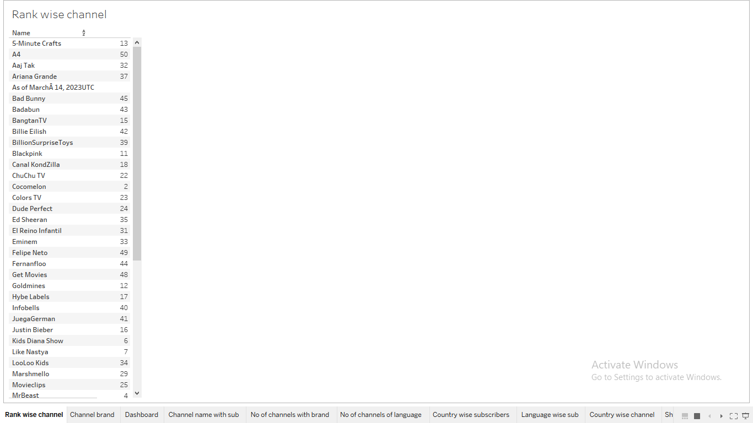

No of channels with Brand

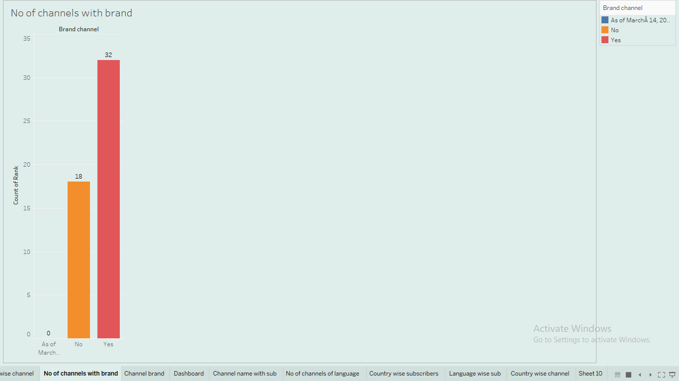

Channel Brand

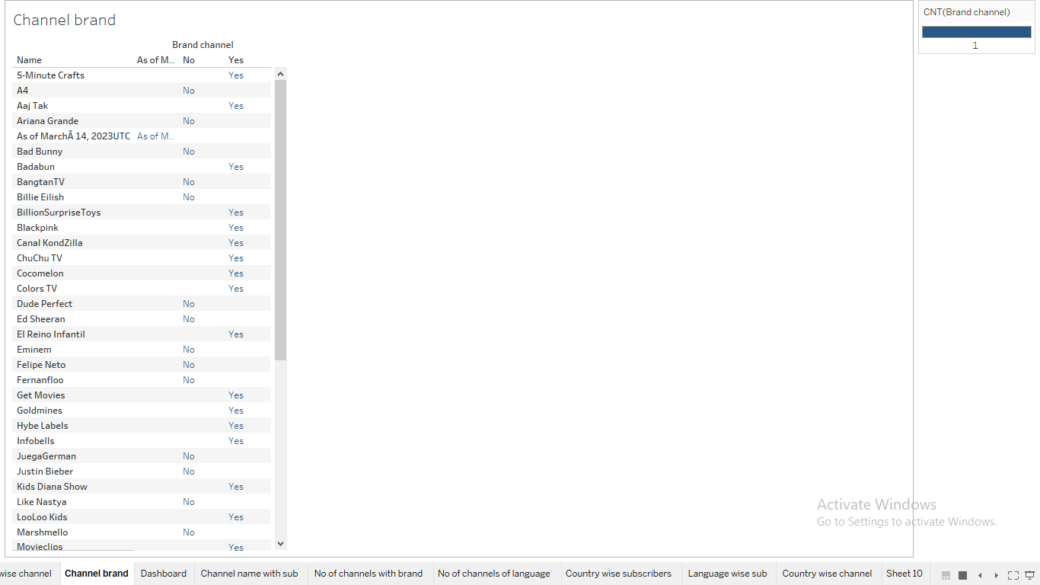

Channel Name with Subscribers

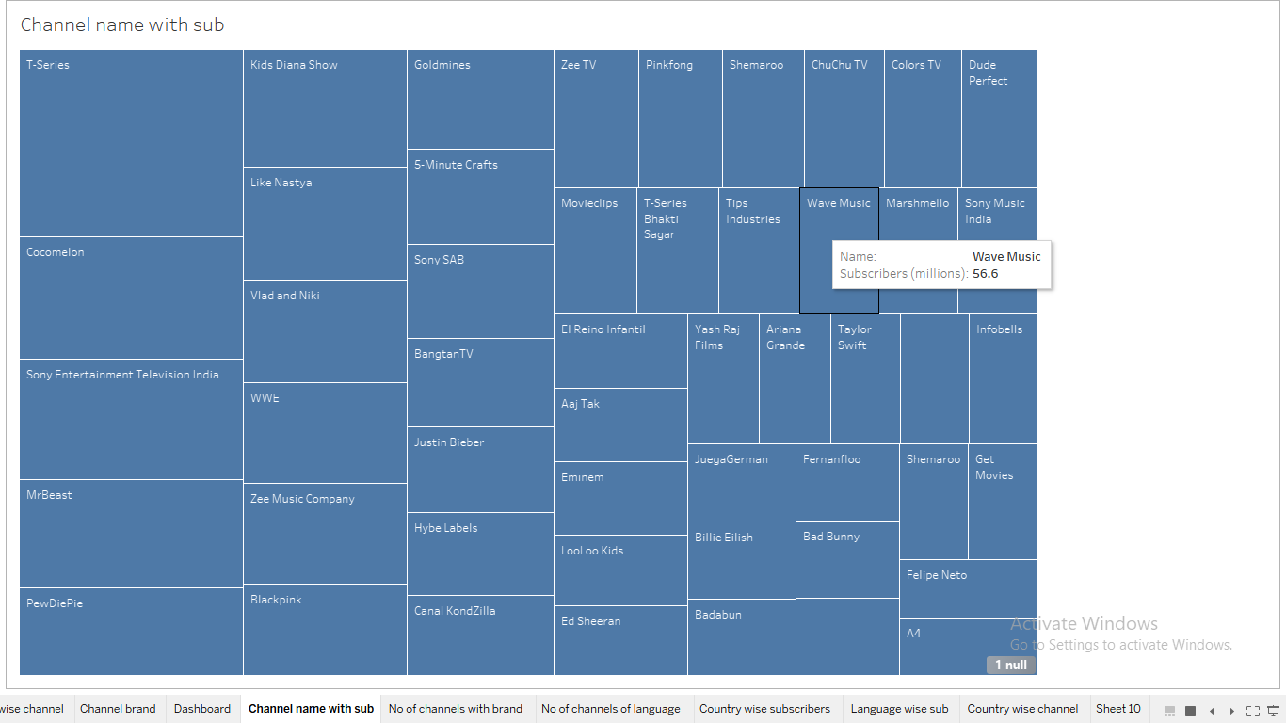

No of channels of Language

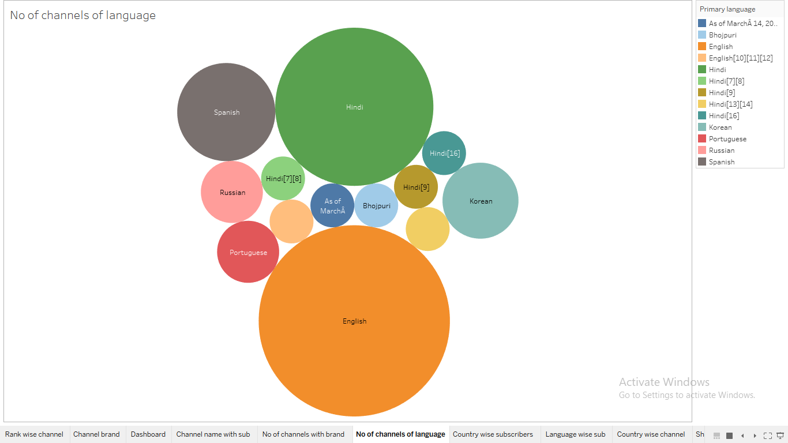

Country wise Subscribers

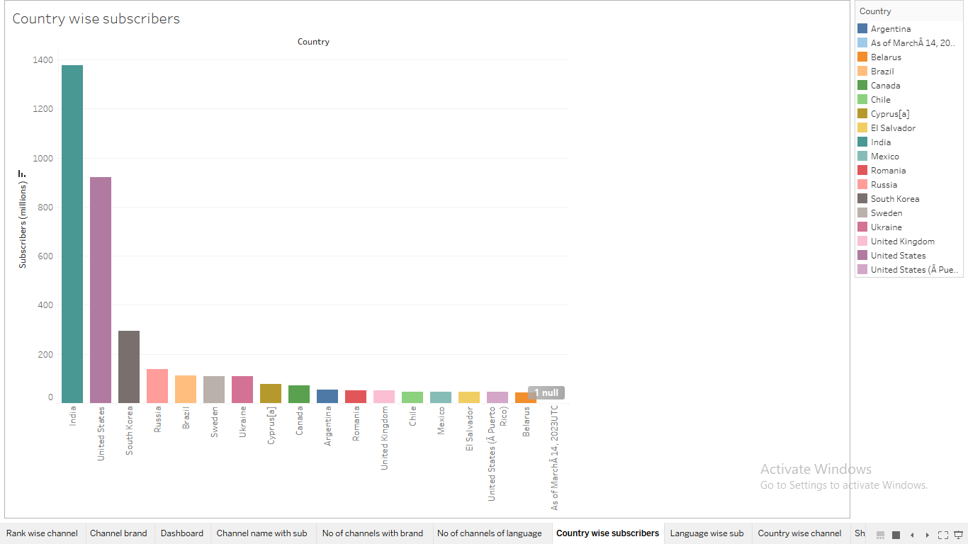

Language wise Subscribers

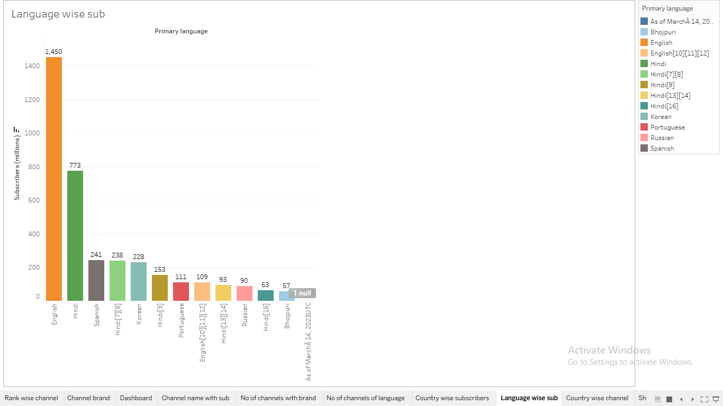

Country wise Channel

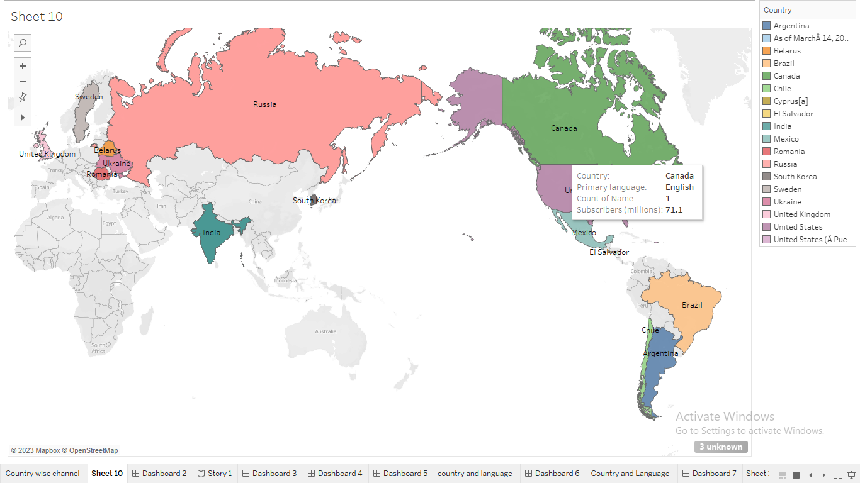

Dashboard

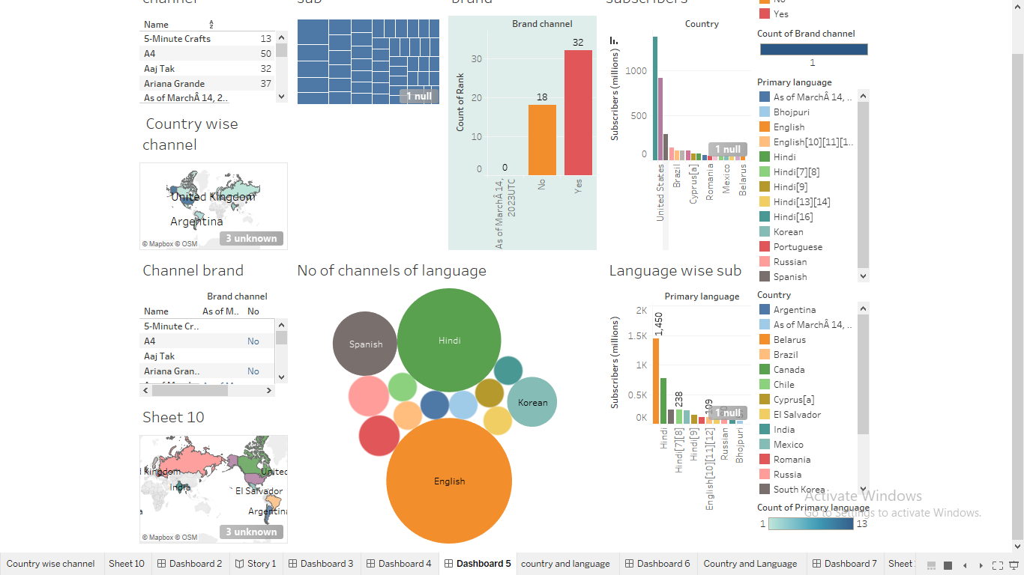

Storyboard

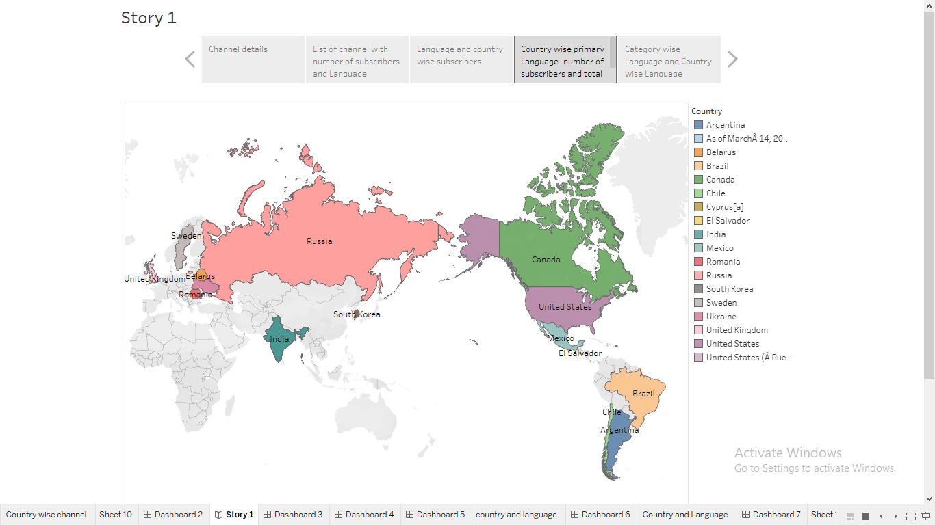

# **4. Advantages and Disadvantages**

* YouTube as an information disseminating platform for students.
* It's the perfect place to learn and gain expertise. ..
* YouTube's user-friendliness. ...
* YouTube for Brand Promotion. ...
* Easy Earning is at the very top of the list of YouTube benefits for Vloggers.
* Ads- a drawback of YouTube for the audience. ADVERTISEMENT.
* A lot of distraction. ADVERTISEMENT. ...
* Obscenity- one of the biggest drawbacks that YouTube has. The kind of content that is uploaded on YouTube is largely in control today. ...
* Defamation and Bullying. ...
* Making money isn't that easy

# **5. Applications:**

Educational videos can apply on YouTube in teaching however, some authors have to worry about the security and validity of online videos. Kay (2012) states that videos involve positive attitudes, management of the learning process, enhancement of reading and study behavior, and the performance of students. Nevertheless, he outlines the disadvantages of using videos in learning. These are less class participation, referring to orthodox teaching, and technical problems. Recommendations made that future studies focus on providing empirical evidence on the influence of online video and new media in the learning process.

**6. Conclusion:**

We concluded that there are many attributes that cause a YouTube channel to become popular, which come with certain rules and patterns. For example, video topics, such as stories, animations, and interviews, proved to be quite unpopular, as none of the top channels had those topics as their most viewed videos. Using observations such as these, we made a decision tree to determine whether a YouTuber’s channel will become popular. We faced many limitation. First of all, there was a limited reliability of several websites in researching the topic, due to its influence largely remaining solely on the Internet. Also, we used a fairly small sample size, in comparison to the hundreds of other popular channels with several million subscribers that we could have also observed, which also somewhat reduces the reliability of our patterns and conclusions. In addition, another limitation faced was the fact that the data is unstable, as it is constantly changing. For instance, the number of subscribers and views a video gets is not a static variable. As time goes on, the number of subscribers will fluctuate, and the number of video views will increase. . As there is still much left to explore with regard to the current topic, future research could contribute to our knowledge by developing theories that deepen our understanding of the factors that determine the characteristics of online social information. This could be done by expanding the present study through the investigation of social information on other online platforms. Although social information constitutes a major part of YouTube’s content, it also plays an important role on other social media, such as Facebook. A notable difference between YouTube and Facebook is that while on the first platform users are exposed to social information that is mainly created by strangers, on Facebook this social information is created mostly by acquaintances. Research indicates that this factor may alter how users respond to social information created by others. Hence, investigating social information on other platforms such as Facebook can broaden our insights into the factors on which online social information’s characteristics depend.

**7. Future scope:**

YouTube has been using AI and machine learning to improve the user experience, such as recommending videos and improving search results. This trend is expected to continue, with YouTube investing in more advanced AI technologies to enhance the platform further. YouTube in India is good as a full time career with endless amount of possibilities. But it requires research, hard work, dedication, consistency etc. to be a successful you tuber. YouTube as a career is definitely rising as a current sensation. It does have a lot of scope, exposure and of course, leads us to popularity and fame in your field of choice. The present study contributed to our knowledge by exploring to what social information YouTube users are exposed and how this depends on the type of video that they watch.